2 Initialize a Git Repository
mkdir gitdir
git init

3 Add files to the repository
git add myfile myfile1 myfile2

4 Unstage 1 file
git rm --cached myfile

5 Commit the file
git commit

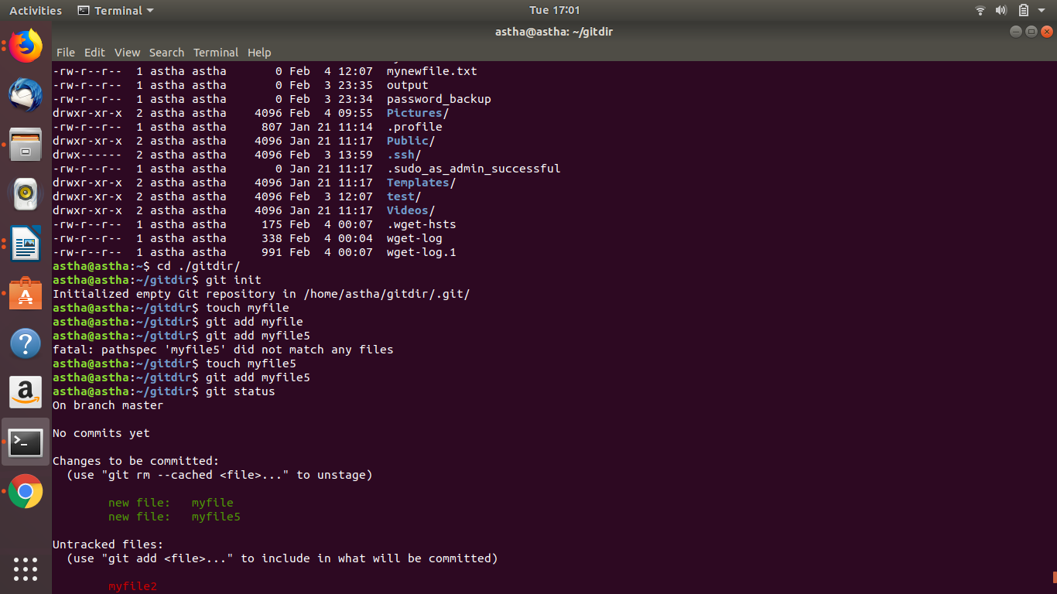

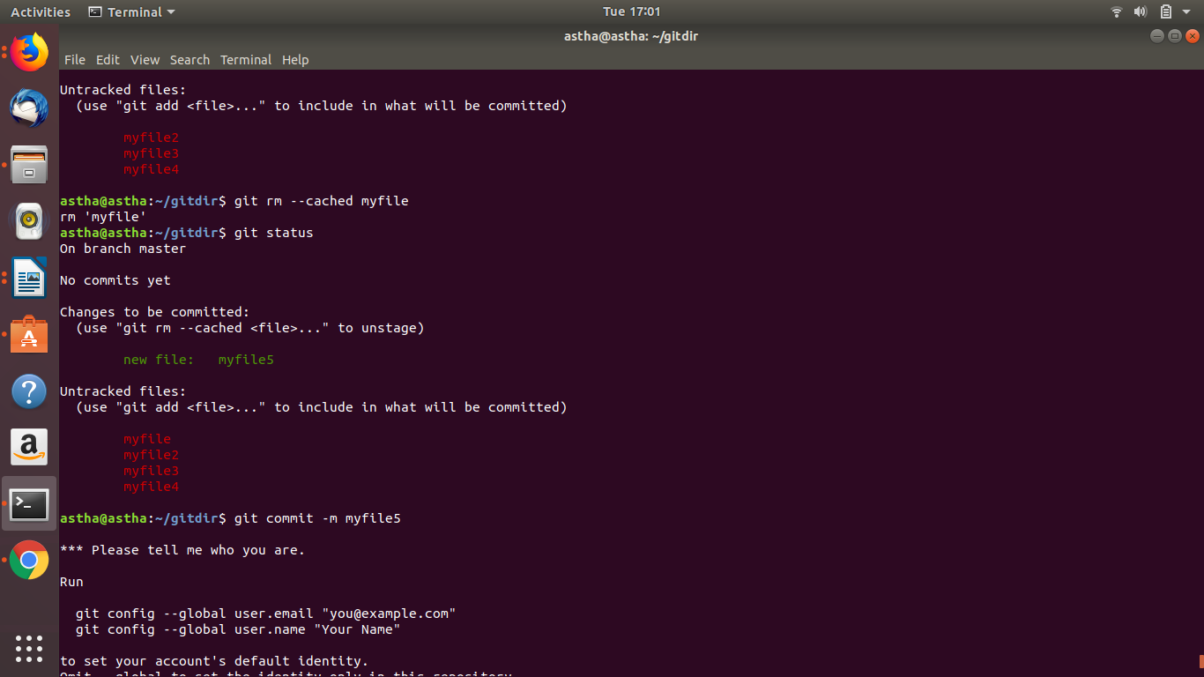

6 Add a remote

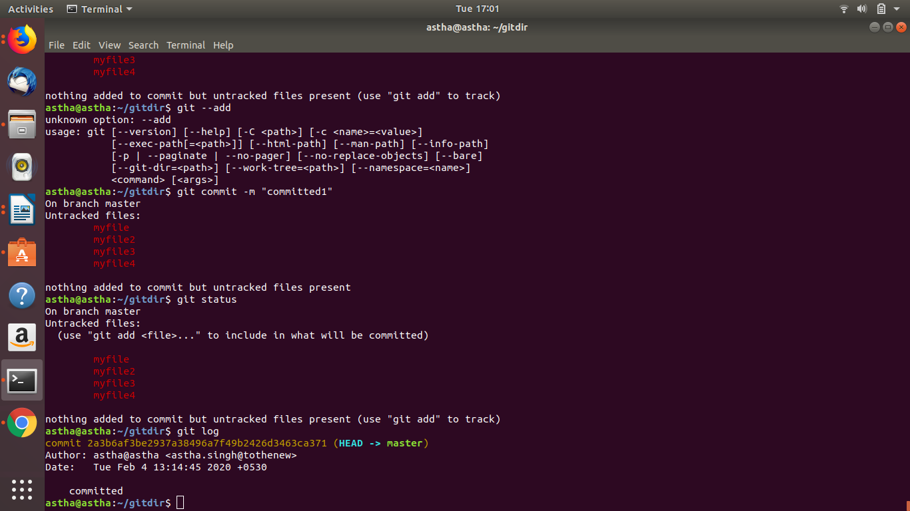

6 Add a remote

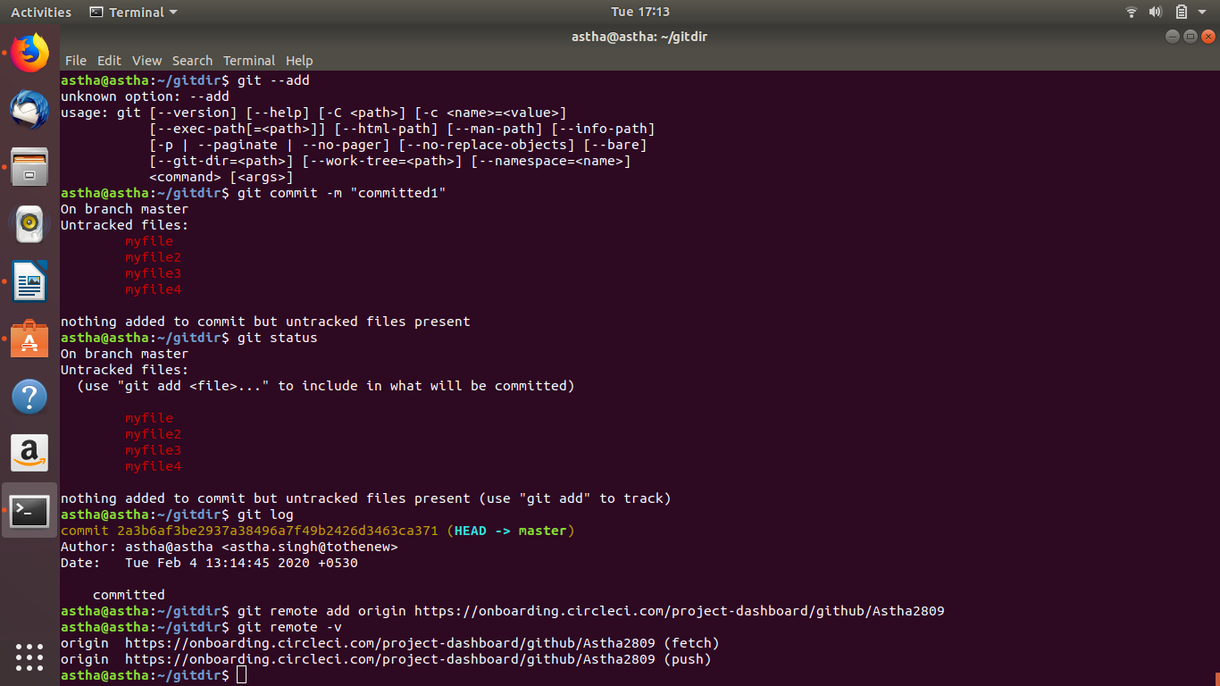
git remote add origin https://onboarding.circleci.com/project-dashboard/github/Astha2809
git remote -v

7 Undo changes to a particular file

8 Push changes to github
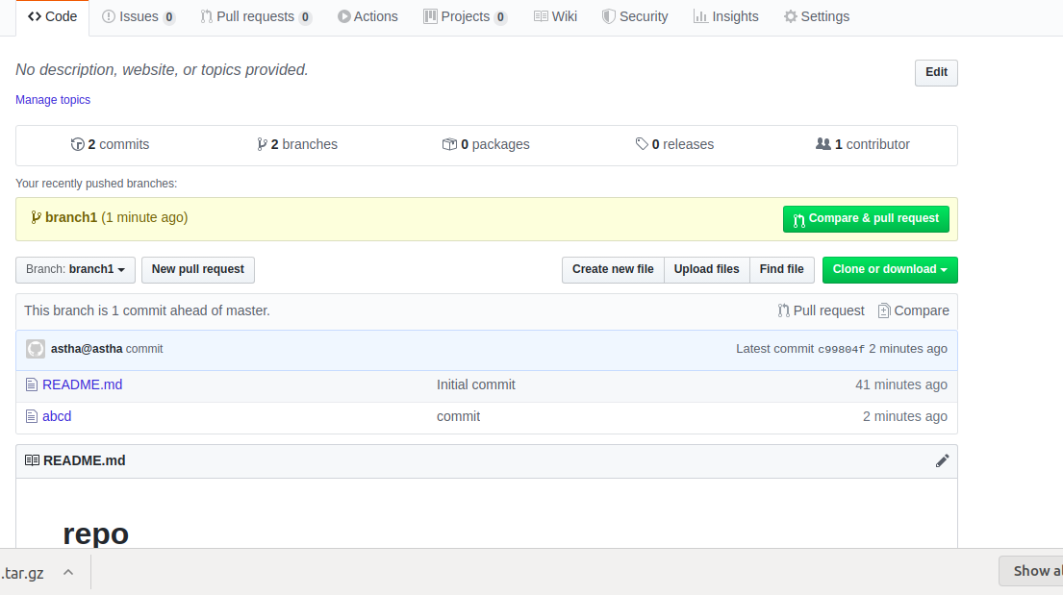

9 Clone the repository

git clone https://github.com/Astha2809/repo.git

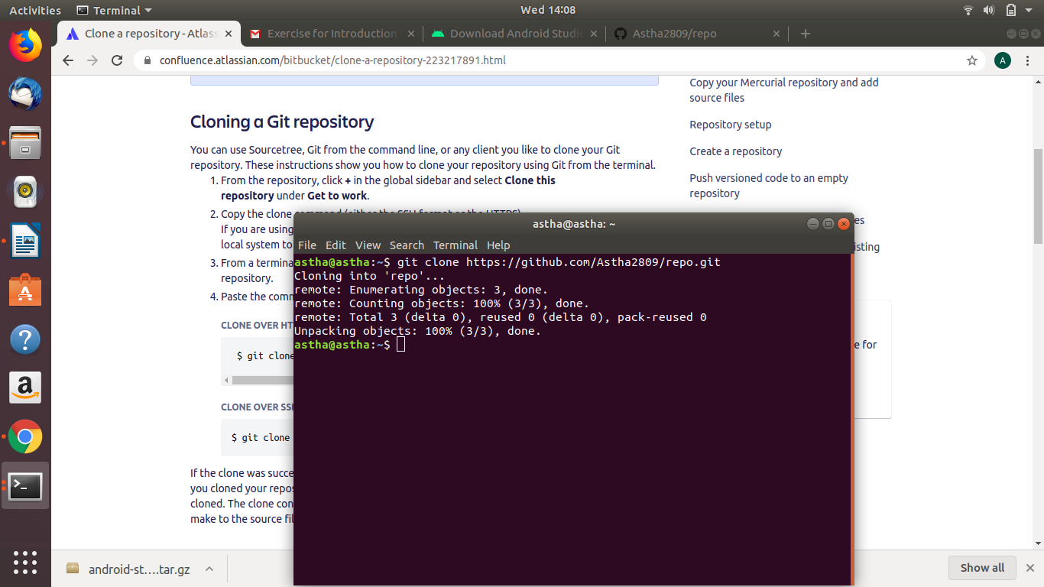

10 Add changes to one of the copies and pull the changes in the other.

12 Ignore a few files to be checked in
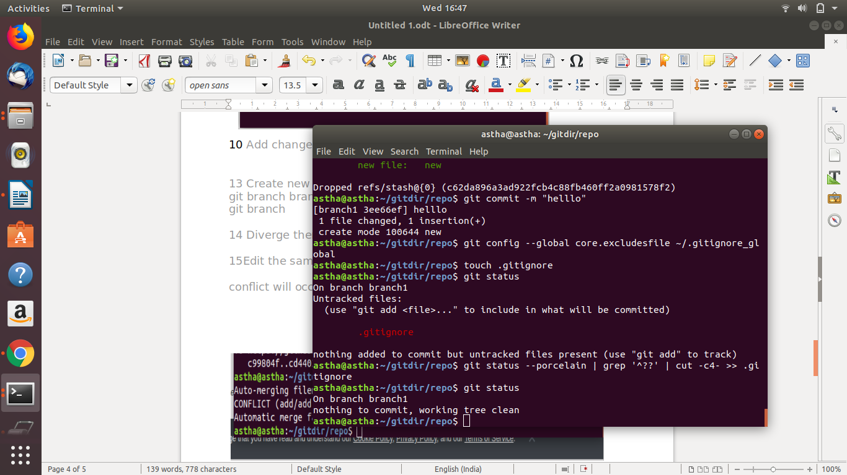

13 Create new branch
git branch branch1
git branch

14 Diverge them with commit

15Edit the same file at the same line on both branches and commit

conflict will occur
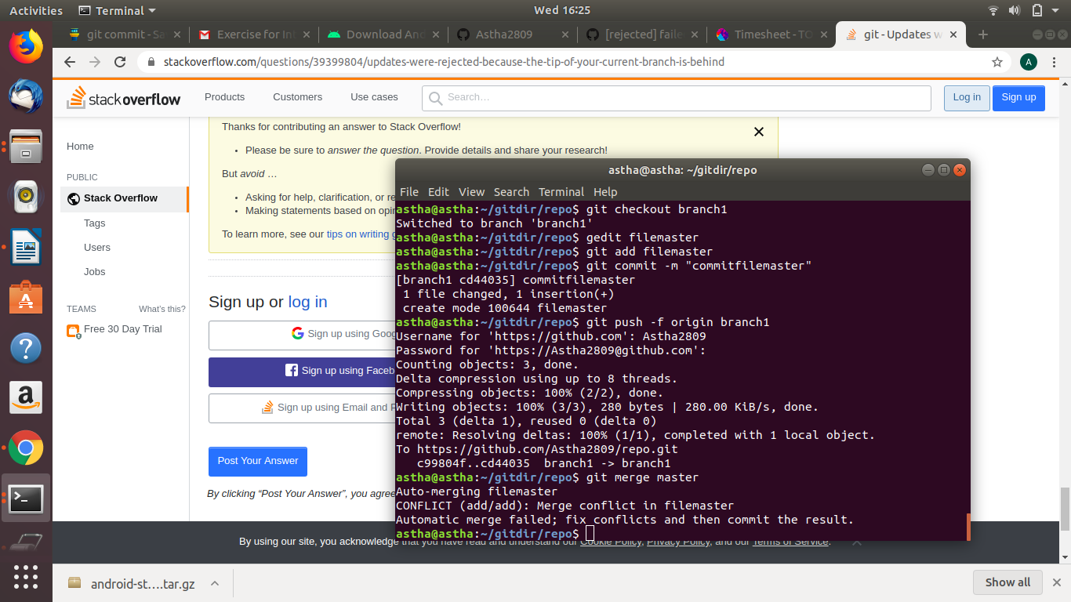

16 Try merging and resolve merge conflicts
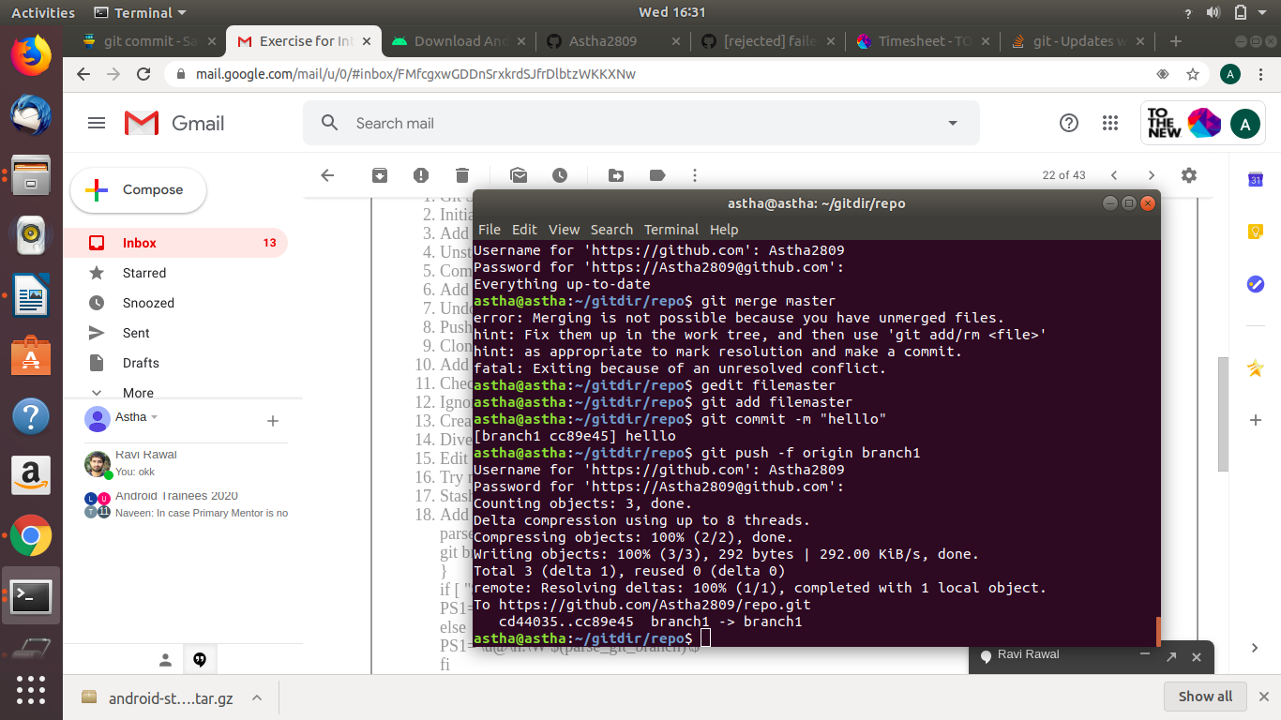

17 Stash the changes and pop them
gedit new
git add new
git stash
git stash pop

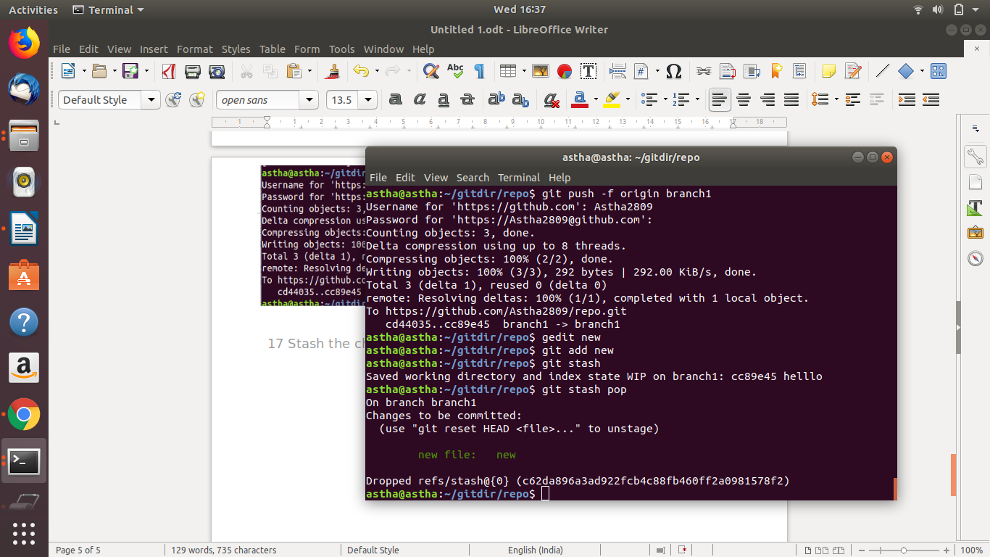

18 Add the following code to your .bashrc file : color_prompt="yes"
parse_git_branch() {
git branch 2> /dev/null | sed -e '/^[^*]/d' -e 's/* \(.*\)/(\1)/'
}
if [ "$color_prompt" = yes ]; then
PS1='\u@\h\[\033[00m\]:\[\033[01;34m\]\W\[\033[01;31m\] $(parse_git_branch)\[\033[00m\]\$ '
else
PS1='\u@\h:\W $(parse_git_branch)\$ '
fi
unset color_prompt force_color_prompt

